CSA 1509
CLOUD COMPUTING AND BIG DATA ANALYSIS FOR IoT
APPLICATIONS
LAB EXPERIMENTS

EXP NO 1: CREATE A SIMPLE CLOUD SOFTWARE APPLICATION AND PROVIDE IT AS A SERVICE USING ANY CLOUD SERVICE PROVIDER TO DEMONSTRATE SOFTWARE AS A SERVICE (SAAS).

AIM:
To create a simple cloud software application and provide it as a service using any cloud service provider to demonstrate software as a service (Saas).

PROCEDURE:
STEP1: GOTO ZOHO.COM
STEP 2: LOGIN TO THE ZOHO.COM
STEP 3: SELECT ONE APPLICATION
STEP 4: ENTER APPLICATION NAME
STEP 5: CREATED NEW APPLICATION
STEP 6: SELECT ONE FORM
STEP 7: THE SOFTWARE HASE BEEN CREATED.

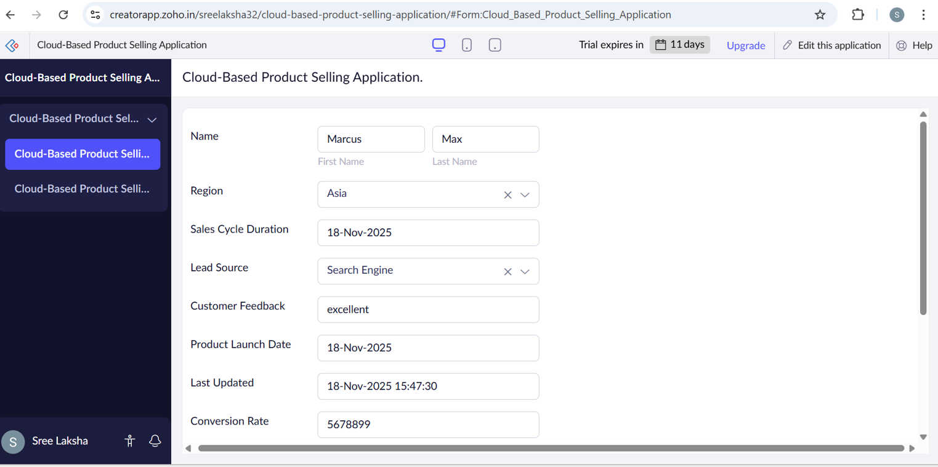
IMPLEMENTATION:

OUTPUT:
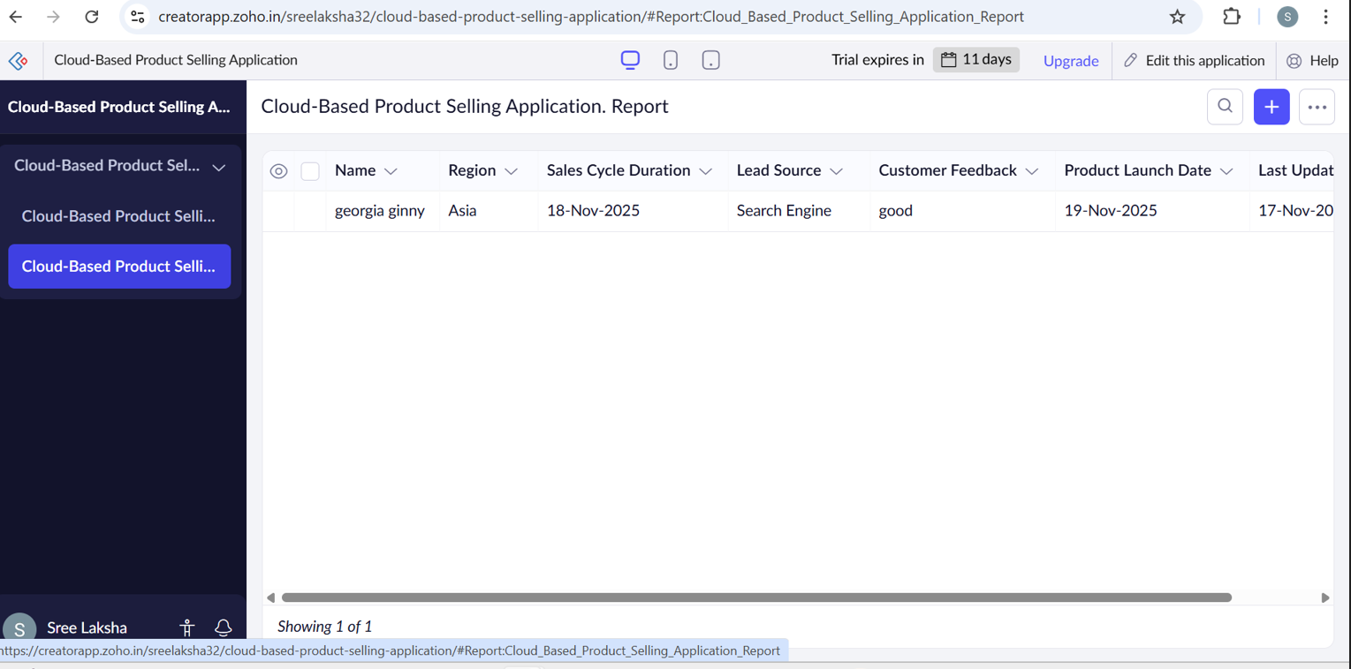

RESULT:
Thus a simple cloud software application and provide it as a service using any cloud service provider to demonstrate software as a service was done successfully.

